1.

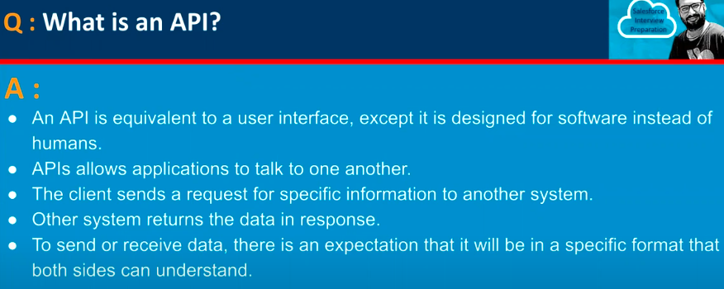

2.

3.

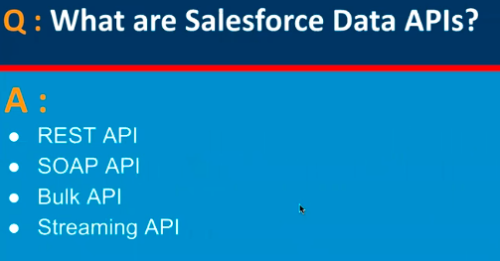

4.

5.

6.

7.

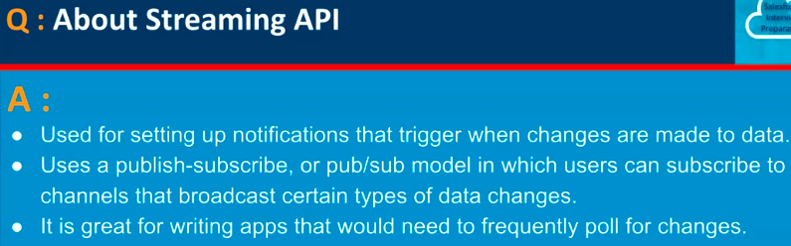

8.

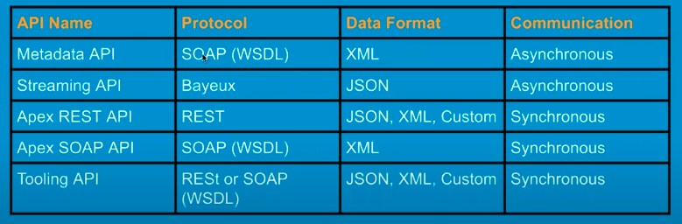

9.

10.

11.

12.

13.

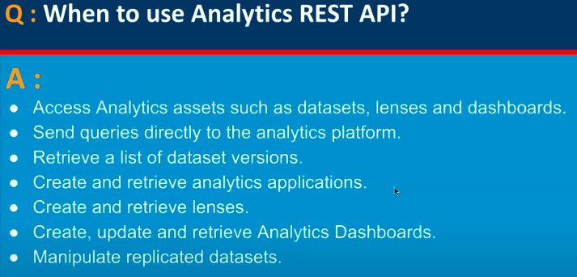

14.

15.

16.

17.

18.

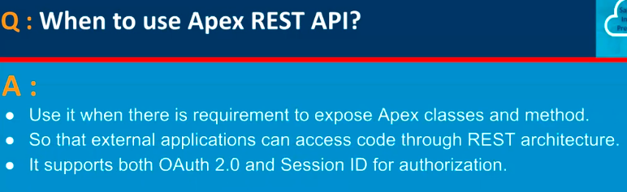

19.

20.

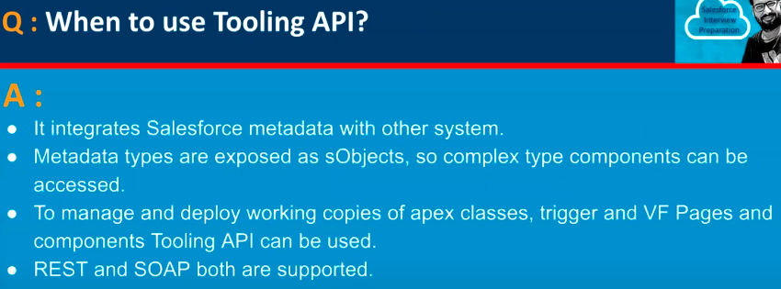

21.

22.

23.

24.

25.

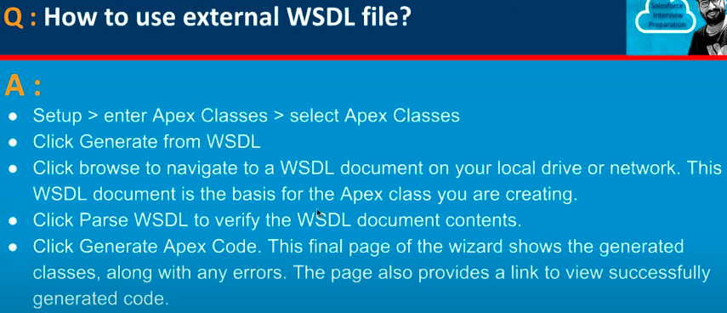

26.

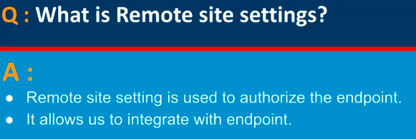

27.

28.

29.

30.

